INSTAGRAM AI WORKFLOW
Script Generation Hands-On Exercise

Structure of Today

Section A - Focus: Idea Identification → Script Writing

Section B - Focus: Footage → Effects → Editing

What You Will Learn
- How to find Instagram-worthy ideas
- How to write engaging hooks, first 3 seconds
- How to generate complete scripts using AI
- How to walk away with a finished script

Overall Workflow
- Idea - Human + AI
- Script - AI
- Footage - AI
- Effects - AI
- Edit - Human

SECTION A

Finding Your Idea and Creating Your Script

Part 1 - Finding Your Idea

Where to Find Ideas
- India Today Tech
https://www.indiatoday.in/technology
- TechCrunch
https://techcrunch.com
- Google Trends
https://trends.google.com

What Makes a Good Idea
- Surprising or counterintuitive
- Can be explained in under 60 seconds
- Published within the last 3 days
- Has a clear takeaway for the viewer

Example Used in This Workbook
"Google co-founder Sergey Brin reveals a secret trick to make AI work better - threaten it."
Source:
https://www.indiatoday.in/technology/news/story/google-co-founder-sergey-brin-offers-tip-to-make-ai-work-better-threaten-it-2733200-2025-05-30

Next step: Develop this idea into a Reel.

Part 2 - Develop Idea into Script
A script has two parts:
- Hook
- Body

Part 2.1 - Creating a Prompt to Generate Hook and Body

Step 1
Go to YouTube
https://www.youtube.com
Search: "Best hook strategy"
Choose any preferred video.
Example:
https://www.youtube.com/watch?v=LmXpbP7dD48

Step 2
Go to:
https://aistudio.google.com
Paste the YouTube link in chat.
Prompt:
Extract the transcript for this video:
https://www.youtube.com/watch?v=LmXpbP7dD48
Model to choose: Gemini 3 Flash
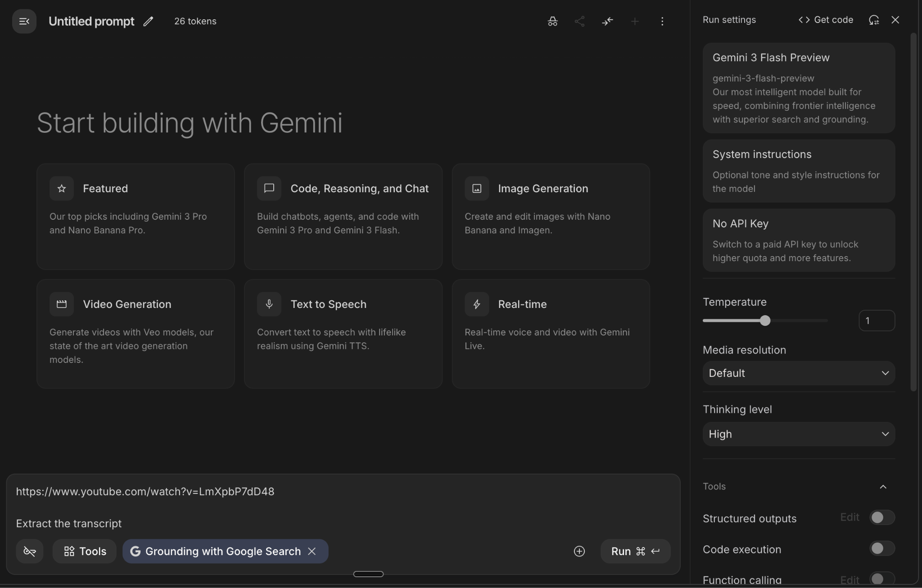

Step 3
After extracting the transcript, reverse engineer it. Go to Claude
Prompt:
Generate a prompt from the attached hook frameworks and common mistakes that can take an idea and its facts as input and generate:
- Multiple hook options
- A complete Instagram Reel body

Part 2.2 - Generate Hook and Script Body

Step 1
Go to:
https://claude.ai

Step 2
Paste the prompt generated earlier.
Then say:
Now generate hooks and a script body for the following idea.
<Paste the full article text>

Step 3 - Optional
Ask:
Give me a clean version without timestamps.

Part 2.3 - Script Generation by Reverse Engineering Writing DNA

Step 1
Collect 2 to 3 scripts from previously created reels.

Step 2 - Extract Instagram Scripts
Tool:
https://screenapp.io/transcription/instagram
Or
https://aistudio.google.com/
Process:
- Upload Reel link
- Allow screen recording
- Stop recording once done
- Transcript will be generated
Note:
To download or copy, a free trial may require card details.
Alternative:
Use the ready-made transcript template already provided in this workbook here

Step 3 - Reverse Engineer Writing Style
Paste transcripts into Claude.
Prompt:
Study these Instagram scripts and reverse engineer the talking style so I can convert any script into this style. Give me the prompt to do that.
Note:
You can skip this step. The writing DNA style is already provided here

Step 4
Paste the script generated in Part 2.2.
Ask Claude to rewrite it in the extracted style.

Script Sample

Google's co-founder just promoted someone he didn't even know existed.

The crazy part? He let AI make the decision.

So, here's the thing.

Sergey Brin — yeah, the guy who built Google — went on the All In podcast and dropped a bomb.

He's been using AI to read through internal group chats.

Not to spy. To find out who's actually doing the work.

One day, he asked the AI a simple question:

"Who deserves a promotion in this chat?"

The AI didn't flag the loudest voice in the room.

Nope.

It picked a quiet engineer. A woman who barely spoke in meetings.

Brin admitted it himself: "I didn't even know she existed."

But here's where it gets interesting.

He took it to her manager.

The manager's response? "Yeah, you're right. She's been crushing it."

She got the promotion.

Think about it.

No office politics. No brown-nosing. No "visibility hacks."

Just pure output.

Brin's takeaway hit hard. Quote:

"Management is actually one of the easiest things for AI to handle."

Here's the bigger picture.

The era of "being seen" to get ahead? It might be ending.

AI doesn't care if you're loud.

It cares if you deliver.

Save this if you've ever felt overlooked at work.

Follow for more on how AI is rewriting the rules of the office.

SECTION B

After Session - Next Steps
You now have your script.

Part 3 - Create the Main Footage (A Roll)

Part 3.1 - Create Voice
Tool:
https://elevenlabs.io
- Record your voice or use AI voice
- Paste script into text-to-speech
- Generate MP3
- Download audio
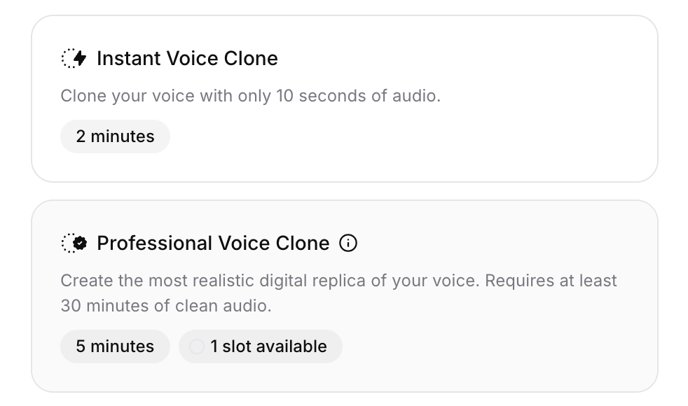
Documentation:
https://elevenlabs.io/docs/overview/capabilities/text-to-speech
ElevenLabs can also generate sound effects.

Part 3.2 - Create AI Clone
Tool:
https://www.heygen.com/academy
Follow academy instructions to create your AI clone.

Part 3.3 - Create A Roll Video
Process:
- Upload script into ElevenLabs
- Generate and download voice MP3
- Go to HeyGen
- Open AI Studio
- Upload the audio file, not the script
- Choose an avatar
- Generate video
Your A Roll video is ready.
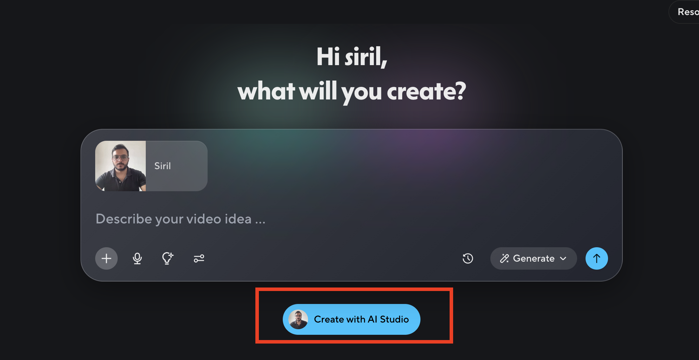

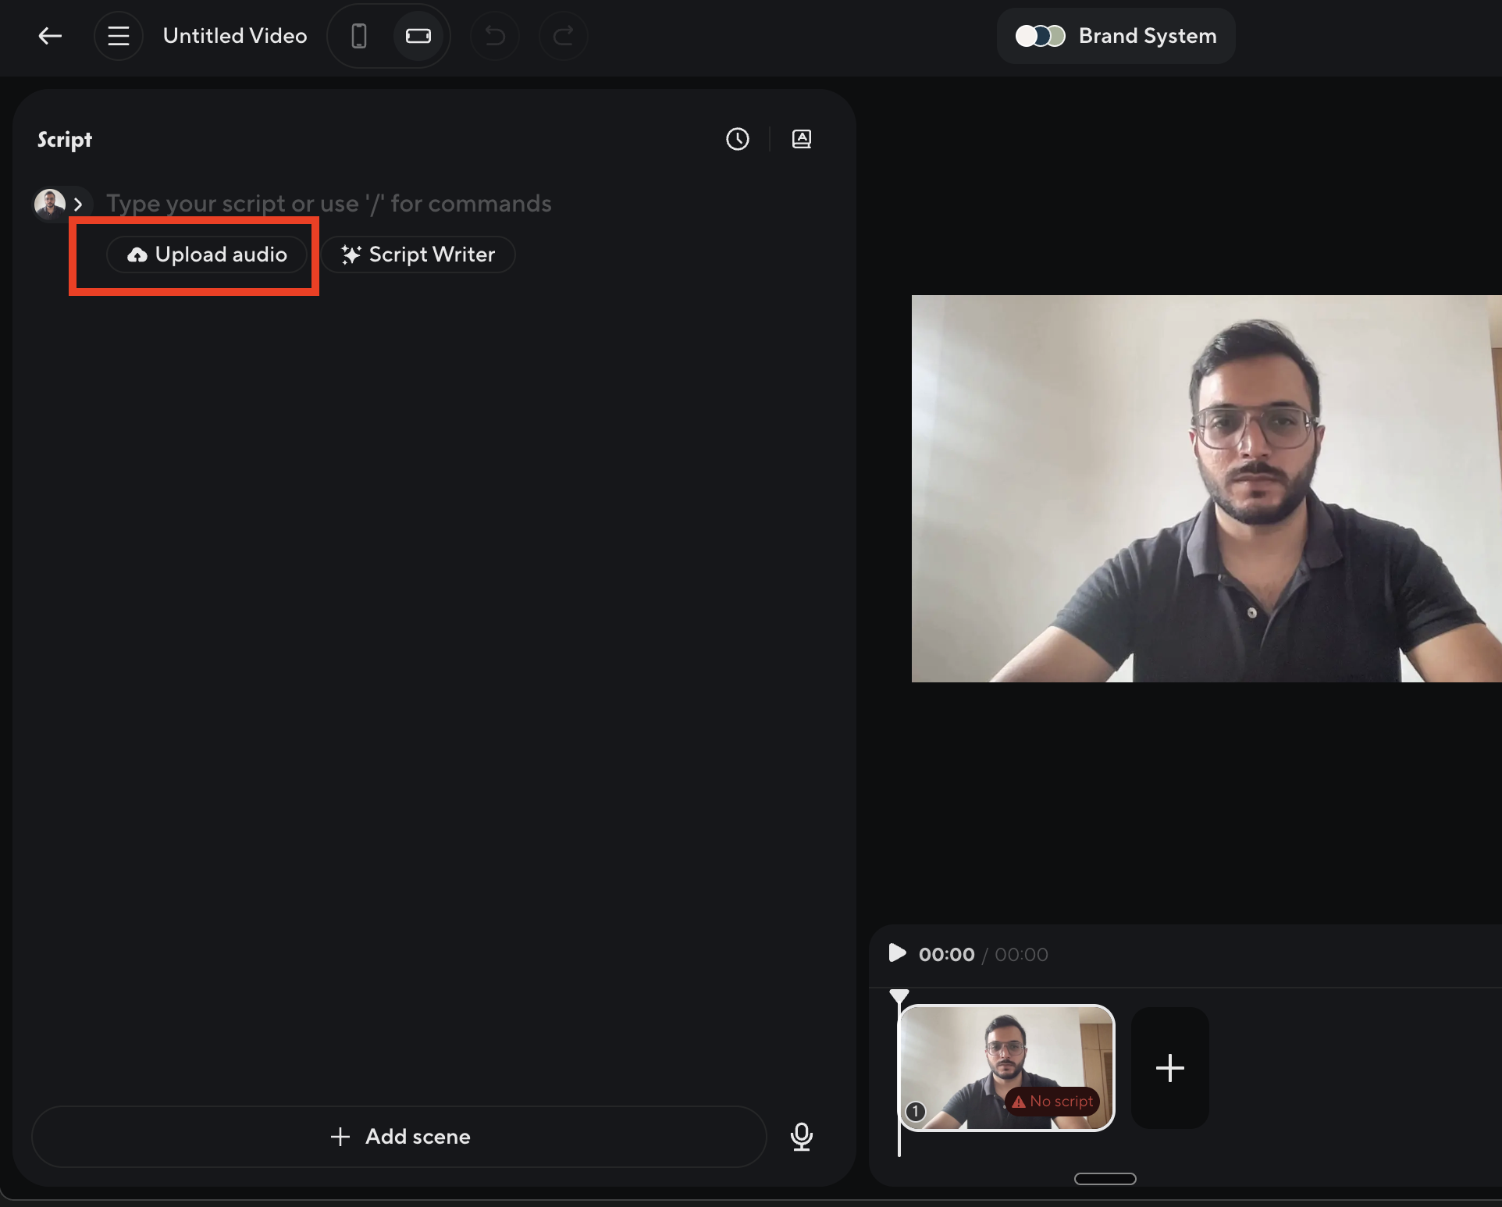
Tool:
https://www.heygen.com

Sample Video Here : https://drive.google.com/file/d/1iJCVaqIc8nFt3nohOKumDNvEC5l0-Wy8/view?usp=sharing

Refer “Optional” Workbook to generate B Roll using this sample video

Part 4 - Add Visual and Audio Effects

Part 4.1 - Generate B Roll
Tool for visual effects:
https://higgsfield.ai/effects
Example:
Choose Fire Lava effect.
Process:
- Create start frame
- Create end frame
- Describe visual transition

Part 4.2 - Generate Music and Sound Effects
Tools:
Suno AI
ElevenLabs
https://pixabay.com/
Optional for this workbook.

Part 5 - Editing
Tools:
https://www.veed.io
or
DaVinci Resolve
Process:
- Upload A Roll
- Upload B Roll
- Add music
- Add text overlays
- Export as MP4
Tutorials:
VEED - https://www.youtube.com/watch?v=RRm_ruS_J_w
DaVinci - https://www.youtube.com/watch?v=LcGsaIV8QBY

